306 8th Ave S Clinton, IA 52732
563.242.8441
www.clintonpubliclibrary.us info@clintonpubliclibrary.us Social Media: @iacpl

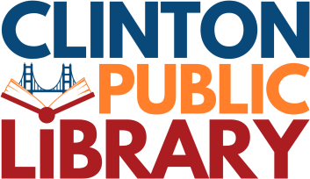
Sustainable Purchasing Policy
The Clinton Public Library is committed to responsible stewardship of public resources and to minimizing its environmental impact. To support this commitment, the library will, whenever practical and efficient, incorporate sustainable and environmentally conscious practices into the procurement of supplies, materials, and equipment.

When making purchasing decisions, Library staff will consider—when applicable and feasible—the following factors (this list is not exhaustive):
- Recyclability of the product and its packaging
- Post-consumer recycled content used in the product or packaging
- Environmental impact of disposal, particularly for items such as batteries, electronics, and hardware
- Transportation impacts, including distance traveled and associated emissions
- Durability and repairability, including whether an item can be repaired, repurposed, or reused rather than replaced
- Sustainability practices of vendors, such as waste reduction efforts, responsible sourcing, or eco-friendly manufacturing processes
Nothing in this policy restricts the library from selecting a product or vendor that is more suitable for the intended use, more cost effective, or otherwise better aligned with Library needs, even if it does not fully meet these sustainability considerations. Sustainable purchasing is an aspirational guideline intended to inform decision making while maintaining operational flexibility.

Adopted by the Library Board of Trustees July 20, 2026

