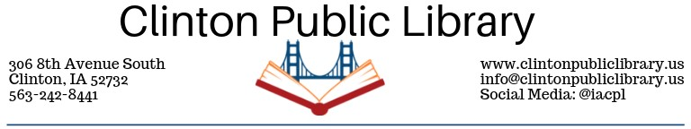
Circulation Policy- Interlibrary Loan
Adopted May 10, 2005; Reviewed July 7, 2010; Reviewed 2015. Revised 11/2019.
When patrons request material not available within the Clinton Public Library (CPL), we ask other agencies to provide it. This is the process of interlibrary loan. Materials borrowed through interlibrary loan have a circulation period which is determined by the lending library, not CPL. We are happy to borrow materials from other libraries for you, but we ask that you respect the date by which those materials must be returned to their home libraries. It is important that materials borrowed through interlibrary loan be returned by the stated date due. Repeated failure to do so could result in patron’s loss of interlibrary loan privilege.
CPL participates in the Interlibrary Loan Reimbursement program for in-state interlibrary loans, and agrees to charge no more than $3.00 for the specific purpose of covering postage costs. For out-of-state interlibrary loans, there is no prohibition on charging the full cost of the loan, the processing fee and the postage back to the customer.
As of November 2019, the Board of Trustees has opted not to recoup the interlibrary loan costs.

