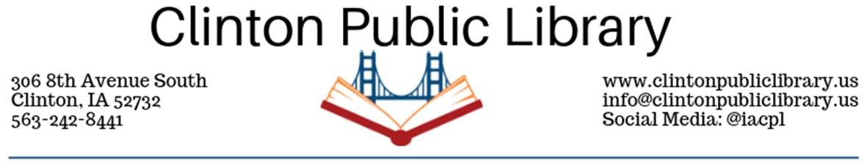Confidentiality of Records Policy
The Clinton Public Library Board of Trustees recognizes that the confidentiality of library records is directly related to the freedom of citizens to read and pursue information without fear of intimidation, and is central to the concept of Intellectual Freedom. To assure citizens free access to information, a library must protect its users from intimidation or harassment which might occur if user records were made available for purposes other than those for which they were intended.
Section 22.7(13), Code of Iowa, states that unless otherwise ordered by a court, by the lawful custodian of the records, or by another person duly authorized to release such information, the following library records shall be kept confidential:
The records of a library which, by themselves or when examined with other public records, would reveal the identity of the library patron checking out or requesting an item or information from the library. The records shall be released to a criminal or juvenile justice agency only pursuant to an investigation of a particular person or organization suspected of committing a known crime. The records shall be released only upon a judicial determination that a rational connection exists between the requested release of information and a legitimate end and that the need for the information is cogent and compelling.
The Library Director or the Director’s designee, as the lawful custodian of library records, (in consultation with the City of Clinton attorney) is authorized to release records that are otherwise confidential “. . . upon a judicial determination that a rational connection exists between the requested release of information and a legitimate end and that the need for the information is cogent and compelling” (Iowa Code 22.7).
The Clinton Public Library will ensure the confidentiality of a patron’s library record and account by limiting access to only approved staff members. Information concerning an individual’s account will be released to that individual only, unless one of the following exceptions applies:
- The Library interprets possession of a card as consent to use it unless it has been reported lost or stolen. If there is reason to believe that consent has not been given library staff will require verification of identity.
- The library will release information to the parent or guardian of a minor child (under age 18) for the purpose of recovering overdue materials and settling accounts for lost, late, or damaged material, and for other matters related to the recovery of material or charges incurred by minor children for which a parent or guardian may be considered liable. However, information will not be provided to the parent or guardian who is merely attempting to determine what library materials a minor child is using.
Policy Reviewed, Revised & Scheduled for review by the Clinton Public Library Board of Trustees
Adopted | Revised | Reviewed | Date of next review
Oct. 1980 | Nov. 1999 | 1991
 | May 2005 | 1999
 | April 20th, 2020 | May 2007
 |  | May 2010
 |  | May 2015
 |  | April 2020

