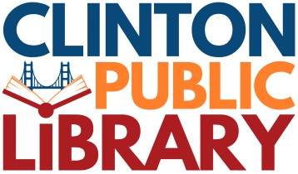
306 8th Ave S www.clintonpubliclibrary.us
Clinton, IA 52732 info@clintonpubliclibrary.us

563.242.8441 Social Media: @iacpl
Disposal of Surplus Library Materials
Library property (i.e., print and non-print materials, equipment, supplies, and/or any personal property) which in the judgment of the Library Director is no longer necessary or useful for library purposes may be disposed of in the following manner:
- Books and non-print materials from the library’s collection, or gift materials, may be discarded, sold, or upon the approval of the Board of Library Trustees be given to local educational or government organizations.
- Any other personal property having an individual current market value of less than $2,000 may, at the discretion of the Library Director, be discarded, turned in on new equipment, or made available for sale.
- In the case of individual surplus items having current market value of more than $2,000, the Board may authorize a trade-in of such items on new equipment or sale of such items or disposal in accordance with Iowa Law.
- No favoritism shall be shown to members of the Board of Library Trustees or library staff, or members of their immediate families, who make bids on or purchase any library item declared surplus.
- Any personal property having a unit value of more than $2,000 will be displayed at the Library for a specified time and a public notice of its availability, the date and terms of the proposed sale shall be posted.

Adopted | Revised | Reviewed | Date of next review
 | 4/10/2018 | 12/2021 | 12/2024
 | 12/2021

