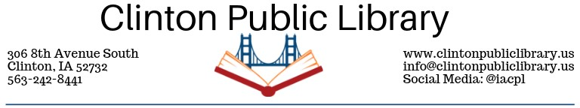
CPL Laminator Policy
Adopted March, 2019. Revised 11/2019.
The Clinton Public Library (CPL) offers laminating service to the public for a small fee. Patrons must fill out the “Agreement for Service” form and sign the “Waiver of Responsibility.” The laminator will be only operated by staff. We reserve the right to deny lamination privileges to patrons for any reason. The information that is to be processed may not represent treason or libel (as proven in court) or pornography. We reserve the right to dispose your lamination if it is not picked up within 30 days of lamination without refund.
Copyright Statement: CPL adheres to the copyright laws of the United States (Title 7 US Code) governing the making of copies of copyrighted materials.

Laminating
The CPL offers lamination service to the public for items up to 24 inches wide and up to card-stock thickness. The small lamination machine uses 8.5”x11” pouches that can do letter or smaller size. Which machine we use is at the discretion of the staff. Any small pieces laminated will come on full sheet, it is up to patron to cut out.
Staff laminates on Tuesday, Wednesday, Thursday with one business day turn around for pick up. Items dropped off on Friday or Saturday will be laminated on Tuesday, unless an appointment is scheduled. Appointments will be taken on Monday and Friday staff time permitting. Please notify the library ahead of time, due to the machine needing 30 minutes to heat up.

Pricing
Payment should be made when materials are left for lamination. You will be charged for the extra film at the beginning and ending of your lamination. These prices will be rounded up to the next foot for any odd length item.
Size | Measurement | Cost
Pouch | 8.5”x11” or smaller | $0.25 a pouch
Laminator | Up to 24” width | $0.50 per foot
Laminator Policy Waiver

Waiver of Responsibility
I understand that laminated items will be exposed to temperatures up to 300 degrees, and that, while not commonplace, items may wrinkle, crease, tear or otherwise become damaged during lamination. I will not hold Clinton Public Library or its employees responsible for any damages that may occur to laminated items. I also understand that lamination is a permanent seal.
Signature: _____________________________________________ Date: _________________

Agreement for Service
Name: ____________________________________________ Phone:____________________
Address: ____________________________________________________________________
Date Needed:__________________________ Length of Item:____________________ Charge:____________________________________ Staff Initials:_________________
To be filled out by library employee:
___________ + 6 = _____________
Round measurement to the nearest foot: _______ x $0.50 = ________ Length of Item Total Measurement
Charge in Inches

