306 8th Ave S Clinton, IA 52732
563.242.8441
www.clintonpubliclibrary.us info@clintonpubliclibrary.us Social Media: @iacpl

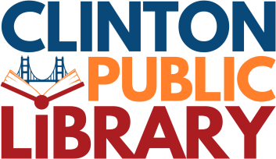
Sustainability Policy
The Clinton Public Library’s Board of Trustees, Administration, and staff recognize the important role libraries play in community conversations about resiliency and a sustainable future. We are committed to reducing our environmental footprint and promoting environmental stewardship at all levels of the organization. Our goal is to minimize our impact and maximize future generations’ ability to live, work, and thrive in a healthy shared environment, with equitable access to clean air, clean water, and natural resources.

We support sustainable principles that strengthen a resilient and sustainable community and library for all residents. To uphold this responsibility, the library will strive for economic efficiency; conserve energy and water; support renewable energy resources; minimize pollution and waste; protect habitats; purchase environmentally responsible products; and encourage environmentally preferable transportation whenever practical and efficient. These commitments extend to all contractors, vendors, and supplier relationships. We will encourage those serving or acting on behalf of the library to meet our standards of environmental performance.

Employee understanding and involvement are vital to the success of this policy. Administration and the Board of Trustees will encourage staff to be proactive and apply sustainable thinking across facilities, operations, policy development, technology, programming, and community partnerships. All employees will receive a copy of this policy upon hiring and will be educated about, and participate in, the library’s ongoing sustainability efforts.

The library embraces the “triple bottom line” definition of sustainability: practices must be environmentally sound, economically feasible, and socially equitable. These three elements guide all aspects of our sustainability work and help ensure that our decisions promote long-term resilience and responsible stewardship of public resources.
The Board of Trustees pledges its ongoing commitment to supporting sustainable principles grounded in the triple bottom line, ensuring that the Clinton Public Library continues to foster a responsible, equitable, and sustainable community through its collections, programs, and services.
Adopted by the Library Board of Trustees July 20, 2026

